**CSS Lab Assignments**

**Q1) Design a Login Page and Apply style using CSS as in the image below.**

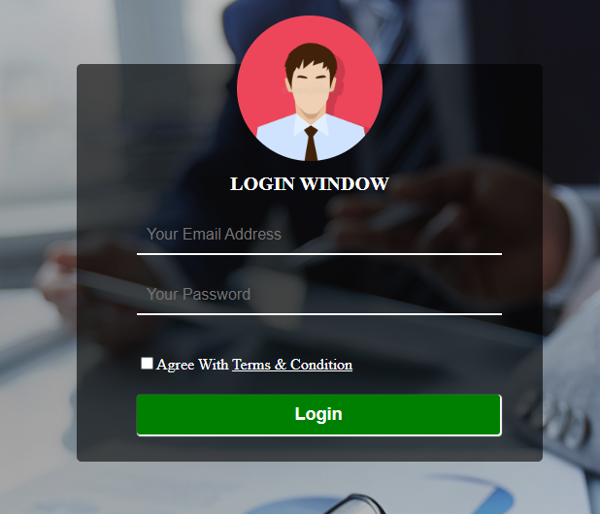

**Q2) Design a Home Page and Apply style using CSS as in the image below.**

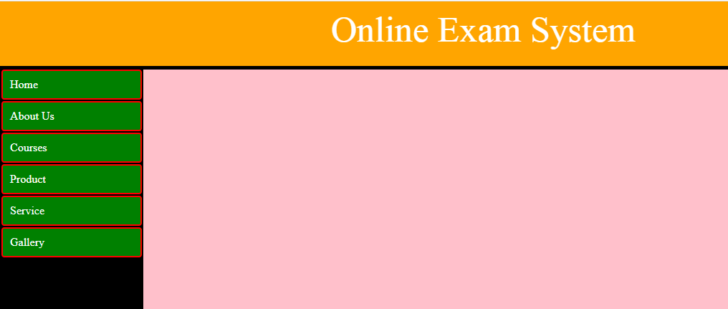

**Q3) Design a Photo Gallery Page and Apply style using CSS as in the image below.**

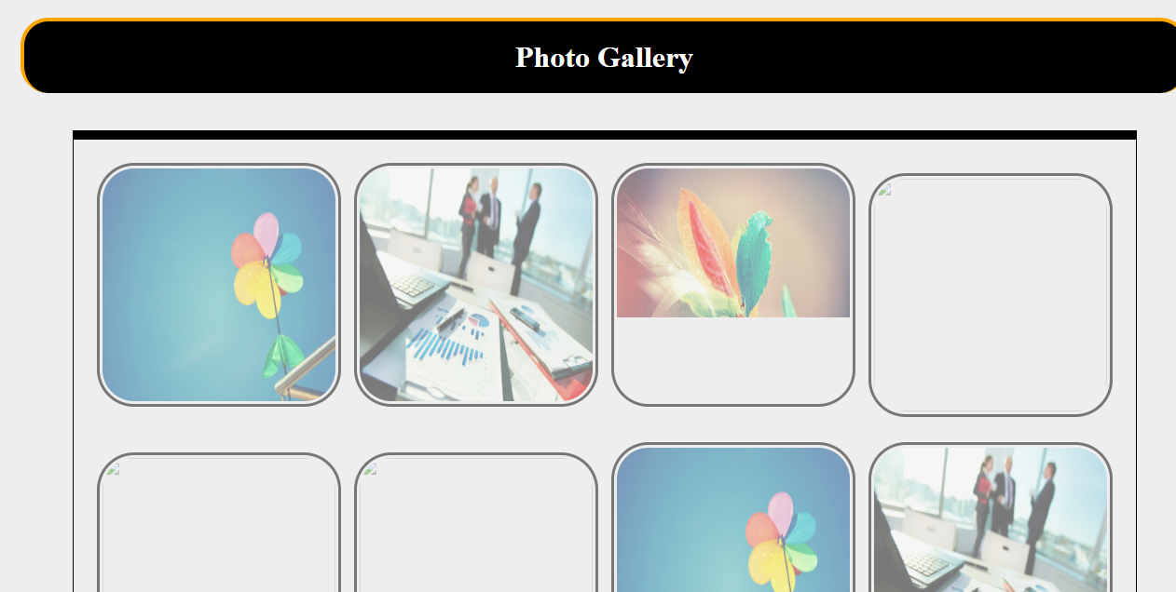

**Q4) Design a calculator and apply the style as like the given image.**

